PETE MATTILA
Sculpture 2023

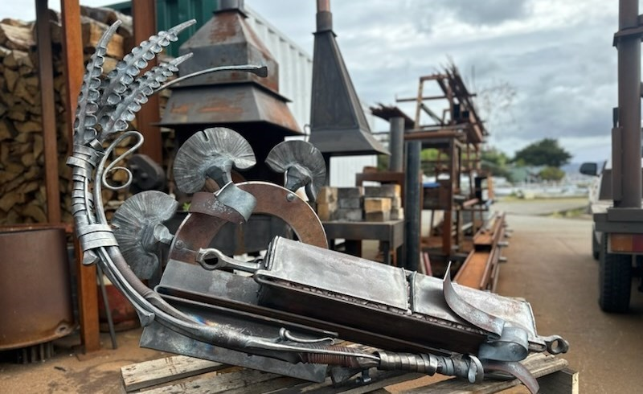

Pete Mattila
Vessel 001 Mt Owen Profile and Density
Forged steel and stones Mt Owen
100 x 150 x 60 cm
$12000
Entry for major award (Inside or outside work)

16

